In the Studio: Wang Qingsong
by Christopher Phillips,
September 2010 issue of Modern Painters

In a studio building in Beijing’s Caochangdi district, the artist Wang Qingsong and his assistants are slathering freshly mixed mud onto a dozen nude and seminude men and women. It’s late afternoon on day eight of a production marathon meant to yield a single 130-foot-long photo work titled History of Monuments. The models, who have been waiting patiently for most of the day, are now being called in groups to a towering picture frame, 12 feet high and 36 feet wide, that encloses a mud-covered rectangle of Styrofoam blocks. After mounting a movable platform, they climb carefully into cutouts in the blocks. Guided into position, the central group solemnly mimics the Hellenistic sculpture of the Trojan priest Laocoön and his sons in their death struggle with serpents sent by the goddess Athena.
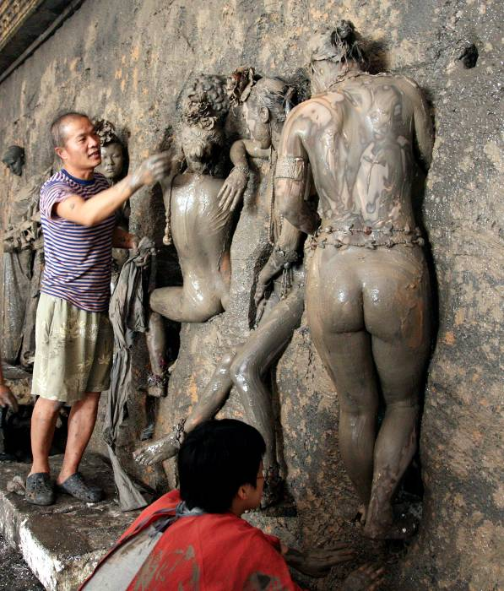
When all the cutouts are occupied, the spotlights are adjusted, the positioning in the vignettes checked one last time, and at last a set of 8-by-10-inch color negatives is exposed. The models are quickly helped down from the frame; some have to be carried because their legs and arms have gone utterly numb from holding rigid poses for more than half an hour. As the models shower and prepare to head home, Wang confers on the next day’s activity with his production assistants, his stylist, his camera operator, and the videographer documenting the shoot. At the end of the planned 15 consecutive days of photographing, the resulting images will be digitally stitched together, end to end, in a tapestrylike format and printed.
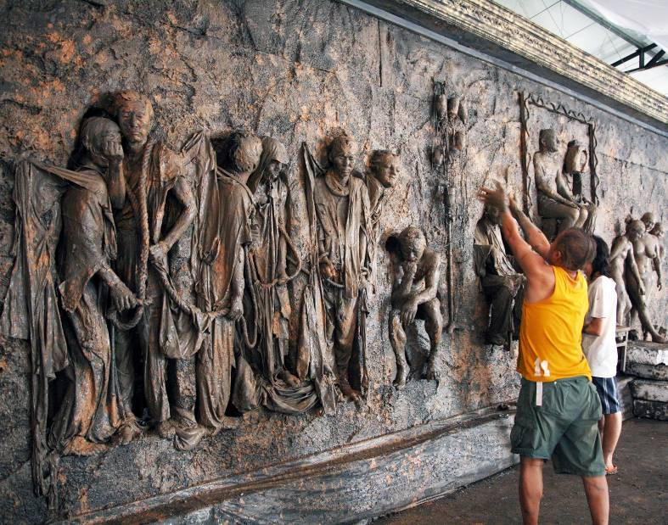
History of Monuments is an epic production even by the standards of Wang Qingsong, who since the late 1990s has specialized in elaborate visual reshufflings of familiar art-historical cards. The completed work will be a parade of faithful re-creations and grotesque parodies of celebrated sculptural classics, including, in addition to Laocoön and His Sons, the Winged Victory, Rodin’s Burghers of Calais, various pietàs, a seated Buddha, and a Degas ballerina, together with Roman portrait busts, assorted discus throwers, straining archers, embracing lovers—and a Duchampian wall urinal.
It is intended as an ironic commentary on the Chinese public’s recently acquired enthusiasm for masterpieces of every epoch and area, with the whole of art history seemingly being swallowed in indiscriminating gulps. Wang got the idea for the piece, he says, while watching the printing operations in a Beijing digital lab. He became fascinated by the 145-foot-long sheets of paper emerging from the machines, each sheet covered with a jumbled lineup of images from different clients, and began planning an enormous work that would fill an entire paper roll. Thinking of the scroll paintings laden with images of historic figures that are found in Chinese museums, he decided to create a sweeping panorama of the great sculptural monuments of past centuries. He set to work armed with a stack of art-history books. The impulse to throw a dark, muddy wash over the whole ensemble arose only later, when he decided to adopt an approach contrary to that of classic sculptors, who rendered their figures in fine materials such as marble and posed them to suggest their noble status. Taking his cue from the mud-soaked scenes he often witnessed on China’s backstreets and in its rural areas, he fashioned a stubbornly “low,” dirty, nonelitist procession.
Such outlandish reversals of art-historical conventions are a staple of Wang’s photo works. Trained as a painter at the Sichuan Academy of Fine Arts, he arrived in Beijing in 1993, just as Chinese contemporary art was beginning to enjoy international attention. He first won recognition as a member of the Koons-inspired Gaudy Art movement, which was championed by China’s most influential art critic, Li Xianting. In 1996 Wang turned to photography because it enabled him to quickly register and comment on the extraordinary economic and social changes that were sweeping—and continue to sweep— China. By 2000 his large photo compositions had begun appearing in exhibitions around the world. Since then his productivity has never flagged, and his works have entered the permanent collections of such high-profile institutions as the Getty Center, in Los Angeles; the Mori Art Museum, in Tokyo; and London’s Victoria & Albert.
Because he uses elaborate studio settings and highly stylized arrangements of models, Wang is sometimes likened, misleadingly, to such contemporaries as Gregory Crewdson and Jeff Wall. A more apt comparison might be to the earlier artist George Grosz, whose works depicting Weimar-era Berlin are similarly filled with needling social observation, sardonic humor, and sometimes grotesque exaggeration. Wang’s attitude to post-Mao China mixes deep-seated attachment to his country with frequent disgust at its boom-era excesses. He ridicules what he calls the “superficial splendor” of today’s Chinese nouveau-riche taste, yet he insists, “I like Chinese civilization. It offers an enormous space for imagination. Things take one form today and then change to another form tomorrow.”
Wang adroitly uses moments from his country’s past to cast an unexpected light on the present. Competition, 2004, for example, grew out of his recollections of the Cultural Revolution of the 1960s and ’70s, when the walls of China’s cities were covered with handmade posters pasted up by rival Red Guard factions. Today a similar and equally intense battle is taking place, but now it is between the billboards of competing consumer brands. For Competition, Wang filled the walls of a rented Beijing movie soundstage with more than 600 mock advertising posters that he drew by hand, mimicking the logos of such companies as Citibank, McDonald’s, Toyota, and their Chinese counterparts. In the completed photograph, the artist is perched on a ladder in front of the visual cacophony of the posters, an old-fashioned megaphone in hand, as if he were addressing a political rally—or shamelessly hawking consumer goods.
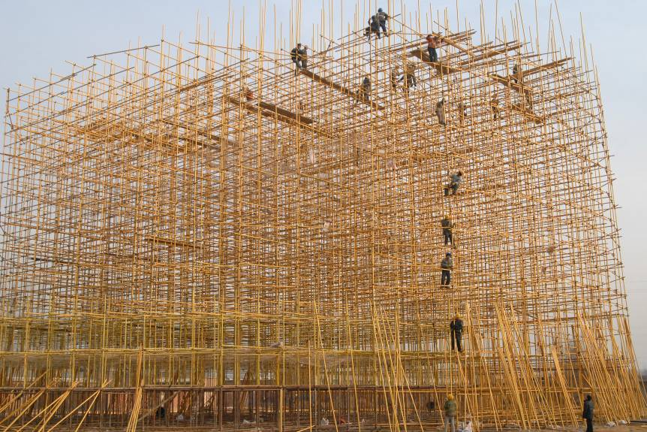
Recently Wang has begun to branch out from photography to video, notably in a series of short works that take his customary themes in new directions. The 2008 video Skyscraper is his caustic response to current efforts by the Beijing municipal government to extend industrial and real-estate development to the surrounding countryside. After leasing a parcel of land in a desolate rural area outside the city, the artist hired a construction crew to erect a 115-foot-tall tower made from scaffolding painted gold and recorded the monthlong process using 35-millimeter motion-picture stock. The resulting work, shown in time-lapse, portrays the dreamlike tower shooting up like a shiny weed in a barren landscape—a hollow promise of a golden future.
Another video from the same year, 123456 Chop, offers an unexpectedly harrowing take on the ephemerality of the flesh. In it the artist’s younger brother appears in a dramatically lit studio and tosses the carcass of a slaughtered goat onto a low wooden platform. Then, wielding butcher’s knives in a fast-motion frenzy of carving, he systematically pulverizes the creature’s remains, until at the video’s end only a thin, painterly layer of red particles is visible on the platform. To underscore the work’s dark, claustrophobic mood, Wang prefers that 123456 Chop be presented as an enclosed room installation.
In his studio in Caochangdi, the artist considers how best to display History of Monuments, whose enormous length will present obvious challenges to any gallery or museum. Since the muddy parade of sculptural history that he has conjured up is purposely low, not elegant, he thinks that the work should be shown casually—perhaps just pinned to a wall or even rolled out on the floor. Why not? Like so many of the best Chinese artists today, Wang Qingsong is convinced that, with perseverance, whatever can be imagined can be accomplished.

